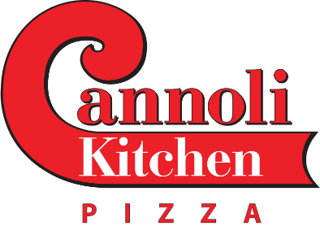
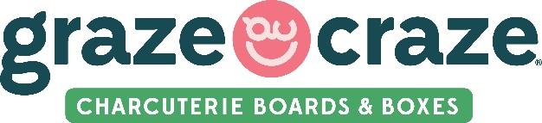
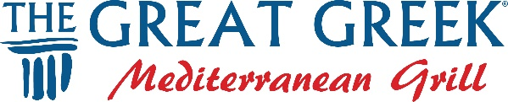

Central Restaurant Products
Door Dash
Olo
Toast
Wild Coffee Marketing
Consolidated Concepts
Edward Don
ezCater
Grecian Delight | Kronos
Lamb Weston
Ovation Up, Inc
Wolverine Packing
Bedre Fine Chocolate
Fully Pormoted Fort Worth
Lake Industries
VerTerra LTD

3M Promotional Products
Advertising Specialty Instiute (ASI)
Alphabroder
American Ad Bag
Ariel Premium
Arome D'Art
BAG MAKERS, Inc
BamBams
CapAmerica
CHAMPRO
Greater Pacific Industries
HPG
Kati Sportcap
Keap
Koozie Group
Logo Mats
OTTO International, Inc.
Portwest LLC
S&S Activewear
Same Day Tees
SanMar
Showdown Dislplays
Sock 101
Tekweld
Twintech Industry Inc

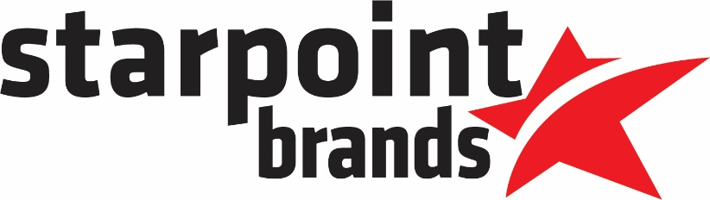

ADP
All That Ship
BooXkeeping Corp.
Business Finance Depot
Comcast Business
Franchise Real Estate group
Gulf Coast Small Business Lending
Gorilla Dash Solutions, Inc.
Heartand Payroll
IDS + Ignite Visibility
J. Galt
LENDZEE
Meridio
Premier Retail Support
Quill
Review Trackers
Revscale Technologies
Ring Central
Tilson PR
POSH

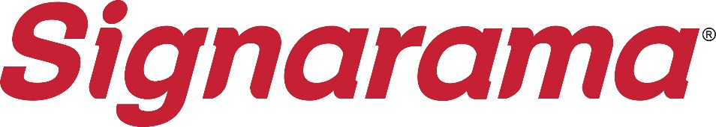

3M
4Ever Products
4over
Advantage Innovations Inc.
Aer-Flo Sports
AnswerConnect
Arlon Graphics
ASP
Avery Dennison
Boe Sign Co., Ltd
BOSS LASER LLC
Canon Solutions America
CareerPlug
Catapult
CET Color
CLN of South Florida, Inc.
CompanyCam
Component Signage
Corebridge
CPC Signs
Direct Color Systems
Elrod Engineering, LLC
Energy Products Distribution
Epilog Laser
Fellers
Fiery LLC
First Impressions International, LLC
GBC SEAL
GCI Digital Imaging
Gemini
General Formulations
Glantz Sign & Graphics Supplies
Grimco
GSG
Howard Industries
HP Inc.
Imaginethis
Impact LED Signs
Integrity Sign Solutions, Inc.
JDS Sign Supply
Keap
Lind SignSpring Group
Logo Mats
MimakiUSA
MKCnext
MR Clipart
MUTOH
North Light Color
Numeritex Displays
Orafol
Orbus Visual Communications
Ornamental Post & Panel
Peachtree City Foamcraft
Plasticade
Print Partners
Ricoh USA, Inc.
Sai Flexi Sign
Showdown Dislplays
Sign Fab Inc.
Stouse, LLC
StratoJet
Summa America
The Sign Pack
Trotec Laser
Vanguard Digital Printing Systems
Versalift
Vision Engraving & Routing Systems
Vista System LLC
Wensco Sign Supply
Yellowpop

Netreputation
Morgan Stanley
Acclivity Financial
Benetrends Financial
BizBuySell
BizProValue
Byline Bank
CapForge
Carman Law & Business Capital
CFC
ClientsIO
CreditBench Powered by BayFirst
Customers Bank
FBCO Bank
FSB Small Busienss Lending
Huntington National Bank
Ivanhoe Capital Advisors
Live Oak Bank
Main Street Funding Group
Michael Drath - Insurance
MOD Assistants
Morgan Stanley
MultiFunding
Netreputation
NewtekOne
One Source Business Capital
Red Rock Tax & Consulting
Sellwithotto.ai
SOCi, Inc.
TBA Ad Fund
United Franchise Group
X2 Engine

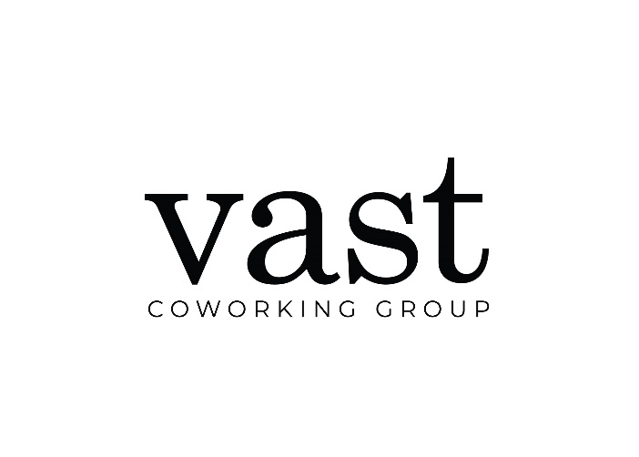
215-Marketing
Agam
Big Red Jelly
CDO Group
Commercial Lighting Industries
Doors22
IDS + Ignite Visibility
iWorkPaceMail with iPostal 1
R&R Construction
Real Time Feedback
ShawContract
Vari
Whitsitt Interiors + Architecture
Yardi Systems

